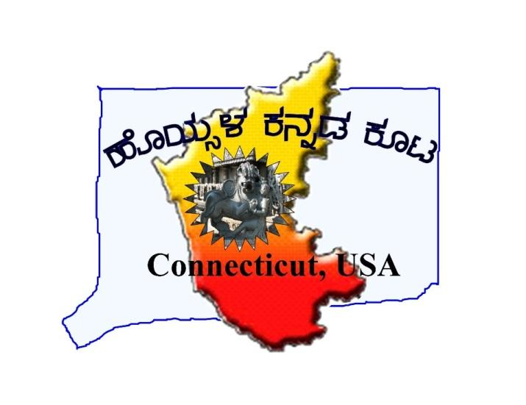
J

HOYSALA KANNADA KOOTA
STANDARD OPERATING PROCEDURE
DECEMBER,2018

Contents
1. Initial Pre-Planning 2
2. Budget 2
3. Event Planning Committees 3
4. Cultural Committee 4
5. Food Committee 4
6. Registration Committee 6
7. Sponsorship Committee 6
8. Audio Committee 7
9. Photography & Video Committee 7
10. Marketing Committee 8
11. Decoration Committee 8
12. Digital Committee 8
13. Kids Management Committee 9
14. Trophies & Certificate Committee 9
15. Logistics Committee 10
16. Special Communications 10
17. Youth Committee 11

Initial Pre-Planning
Event pre-planning stage. Goal is to finalize event date and venue. Estimated start date is around 12 weeks prior to the event.
Ref # | Description | When | Owner | Status | Comments/Tips
1 | Explore options for the event date | ~12 weeks prior |  |  | Check for other community events
2 | Setup event venue committee
3 | Submit options to EC (WhatsApp or email)
4 | Call for EC meeting (if needed)
5 | Finalize the event venue
6 | Insurance Requirements
7 | Weather - Rain/Snow day
8 | Send the Save the date email

Budget
Here we are doing the financial planning. Usually treasurer will propose the income and expenditure estimates.
Ref # | Description | When | Owner | Status | Comments/Tips
1 | Estimate the overall budget | ~10 weeks prior | Treasurer |  | Check the previous event budget
2 | Cost - External artists | $0
3 | Cost - Food | $1000
4 | Cost - Cultural | $50
5 | Cost - Venue | $750
6 | Cost - Trophies | $0
7 | Cost-Certificates | $0
8 | Cost- Decoration Committee | $100
9 | Cost -Registration Committee | $50
10 | Cost- Kids Management Committee | $50
11 | Income – Ticket Sales |  | $1500
12 | Income - Sponsors |  | $750
13 | Propose the budget to EC and get approval

Event Planning Committees
Set up the various committees and distribute the work load
Ref # | Description | When | Owner | Status | Comments/Tips
1 | Event Committees | ~8 weeks prior | Secretary
2 | Cultural Committee
3 | Food Committee
4 | Registration Committee
5 | Sponsorship Committee |  | Sadanand
6 | Audio Committee |  | Pradeep
7 | Photography & Video Committee
8 | Marketing Committee
9 | Decoration Committee
10 | Digital Committee |  |  |  | Website,FB,Signage,evite  Flyer
11 | Kids Management Committee
12 | Trophies & Certificate Committee
13 | Logistics Committee |  | Pandurang

Cultural Committee
Responsible for the execution of the Cultural events
Ref # | Description | When | Owner | Status | Comments/Tips
1 | Get budget from treasurer | ~8 weeks prior | Coordinator
2 | External Artists
3 | Set up program registration page with Website team
4 | Finalize the program participation rules
5 | Send program registration email
6 | Collect audio files
7 | Program line up
8 | Prepare program flyer (to highlight artists)
9 | Publish program guide | 1 day before
10 | Off-Stage events any
11 | Finalize offstage competition rules
12 | send offstage competition registration and rules
13 | Decide MCs (emcees)
14 | Coordinate the program slots with coordinator
15 | Green initiatives

Food Committee
Ref # | Description | When | Owner | Status | Comments/Tips
1 | Get Budget | ~8 weeks prior | Coordinator
2 | Prepare draft food menu
3 | Ask for quotes from the vendors
4 | Explore options to order from India
5 | Finalize the food menu
6 | Kids Snacks
7 | Explore volunteers for cooking from EC first and then outside EC
8 | Communicate menu to EC
9 | Prepare food menu flyer
10 | Coordinate with logistics team
11 | Serving plan
12 | Explore and finalize volunteers for serving
13 | Food plates and cups
14 | Serving spoons and Rice Cooker
15 | Coffee maker and Tea flask | 1 week before
16 | Tea plan and volunteer for making tea
17 | Get the guest count from Registration committee
18 | Get the guest count from cultural committee for Lunch and external artist for Dinner
19 | Coordinate lunch closing ,snack break and dinner open time with Cultural committee
20 | Finalize the quantity
21 | Coordinate Youth Volunteers with Youth committee for assisting on the event day
22 | Confirm Snack packing volunteers
23 | Green Initiative

Registration Committee
Ref # | Description | When | Owner | Status | Comments/Tips
1 | Get Budget | ~8 weeks prior | Coordinator
2 | Propose the event ticket price
3 | Consider any special ticketing situations like Season Pass or external artists sponsorship etc.
4 | Get approval from EC
5 | Get the online registration link
6 | Registration plan
7 | Registration desk decoration
8 | Monitor the registration count and give frequent updates to EC
9 | Publish the registered guest count to EC | 1 week & daily
10 | Set up the Paypal Here app connection
11 | Get the list of Annual Members and Life Members
12 | Any other ideas to improve the registration process, for e.g. gifts, goodies etc.

Sponsorship Committee
Ref # | Description | When | Owner | Status | Comments/Tips
1 | Estimate sponsorship amount to be raised | ~8 weeks prior | Coordinator
2 | Finalize Sponsorship benefits
3 | Publish the Sponsors list - Website
4 | Publish the Sponsors list - FB
5 | Publish the Sponsors list - Email (If any)
6 | Table arrangement for each sponsors on the event day
7 | Plan to facilitate the sponsors

Audio Committee
Ref # | Description | When | Owner | Status | Comments/Tips
1 | Number of mics(wired/wireless) | ~8 weeks prior | Coordinator
2 | Audio mixer
3 | Speakers
4 | Test connection
 | coordinate with cultural committee to get the Audio file and plan for compatibility format test | 1 week before
 | Get Wifi information

Photography & Video Committee
Ref # | Description | When | Owner | Status | Comments/Tips
1 | Identify the volunteers |  | Coordinator
2 | Plan photobooth
3 | Arrange - Cameras
4 | Arrange - Camcorders
5 | Arrange - Tripods
6 | Arrange - Memory cards
7 | Identify the volunteer for video
8 | FB live is (if required)
9 | Collect photos from volunteers | Day after
10 | Upload it to google photos and create albums | Day after
11 | Publish the album link | Day after

Marketing Committee
Ref # | Description | When | Owner | Status | Comments/Tips
1 | Get the program details from cultural committee |  | Coordinator
2 | Prepare the list of people to contact
3 | Make phone calls and ask them to register
4 | Publish the event flyer - FB
5 | Publish the event flyer -

Decoration Committee
Ref # | Description | When | Owner | Status | Comments/Tips
1 | Collect the decoration items |  | Coordinator
2 | Plan for decorations
3 | Setup the stage
4 | Identify volunteers to setup the stage

Digital Committee
Ref # | Description | When | Owner | Status | Comments/Tips
1 | Create Flyer |  | Coordinator
2 | Publish the flyer – Website, FB
3 | Evite – Create evite or Event registration site
4 | Website - Create event page
5 | Website - Publish the page to get the event tickets
6 | Website - Create Sponsorship page
7 | Website - Create Program registration page
8 | Website - Create Placeholder for program guide
9 | Website - Publish the program guide
10 | Website - Consolidate the guest list
11 | Website - Consolidate the program registration list
12 | Signage – Get logo from sponsors
13 | Signage - Making ads to fit both signage and kiosk
14 | Signage - Work with food and cultural committee to get the flyers
15 | Signage - Design/Redesign to fit the kiosk and signage

Kids Management Committee
Ref # | Description | When | Owner | Status | Comments/Tips
1 | Get the budget |  | Coordinator
2 | Identify the venue details for Kids
3 | Plan for kids’ activities
4 | Plan for movies

Trophies & Certificate Committee
Ref # | Description | When | Owner | Status | Comments/Tips
1 | Get the number of trophies |  | Coordinator
2 | Get the number of participants for cultural program | 1 week before
3 | Get quotes and finalize the trophy
4 | Use the standard certificate
5 | Print - Program guide
6 | Check website to get the list of kids who are willing to opt-out from getting hard copy of certification
7 | Print - Certificates | 3 days before

Logistics Committee
Ref # | Get the list from Food committee | When | Owner | Status | Comments/Tips
1 | Get the list from Food committee |  | Coordinator
2 | Cutleries - Bowls, Cups, Spoons, Plates
3 | Burners & Heating sands
4 | Water
5 | Explore Go Green/Biodegradable items
6

Special Communications
This section describes the steps to handle the special community events (happy or tragic).
Ref # | Get the list from Food committee | When | Owner | Status | Comments/Tips
1 | Determine if special communication is required |  | Secretary

Youth Committee
This section describes the steps to handle the Youth Committee member special.
Ref # | Get the list from Food committee | When | Owner | Status | Comments/Tips
1 | Coordinate with various committee to get the counts for youth members |  | Secretary
2 | Reach HKK members to find youth participants willing to volunteer
3 | Maintain database for number of hours for each youth volunteer

